Horse Quotes

“A horse is worth more than riches.”
Spanish Proverb
“Good people get cheated, just as good horses get ridden.”
Chinese Proverb
“A man on a horse is spiritually as well as physically bigger than a man on foot.”
John Steinbeck
“When you are on a great horse, you have the best seat you will ever have.”
Sir Winston Churchill
“It is the difficult horses that have the most to give you.”
Lendon Gray

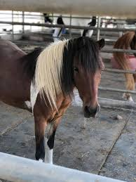
“Horses change lives. They give our young people confidence and self-esteem. They provide peace and tranquility to troubled souls- they give us hope.”
Toni Robinson
“A horse is the projection of peoples' dreams about themselves--strong, powerful, beautiful--and it has the capability of giving us escape from our mundane existence.”
Pam Brown

